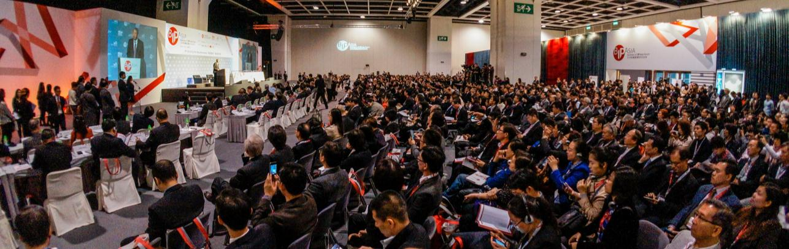

4-5 December 2014
Hong Kong Convention & Exhibition Centre
www.bipasiaforum.com
Business of IP Asia Forum
Intellectual Property : Powering Business Expansion
Jointly organised by the Government of the HKSAR, HKTDC and Hong Kong Design Centre, the 4th Edition of Business of Intellectual Property Asia Forum (BIP Asia)
is returning on 4-5 December 2014 with the exciting theme: “Intellectual Property: Powering Business Expansion”.
Our Chief Executive, Mr C Y Leung, also emphasised in the 2014 Policy Address on promoting Hong Kong as the region’s IP business hub. With the full support from the Government, the Forum last year had attracted over 1,700 industry players from 24 countries and regions to join, featuring 60 heavy-weight speakers to share their insights.
2014 STAR SPEAKERS
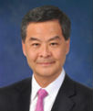 |  |  |  | 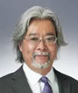 |  | 
The Hon C Y Leung, GBM, GBS, JP  The Chief Executive  Hong Kong Special Administrative Region People’s Republic of China | Mr. Francis Gurry  Director General  World Intellectual Property Organization (Geneva) | Mr. Brian Hinman  Chief Intellectual Property Officer  Philips (Netherlands) | Mr. Kwang Jun Kim  Senior Vice President and Chief Intellectual Property Officer  Samsung Display (Korea) | Mr. Toshimoto Mitomo  Executive Vice President, Intellectual Property,  Sony Corporation  (New York) | Mr. Antony Taubman  Director, Intellectual Property Division, World Trade Organization (Geneva) | Mr. Joo Sup Kim  Vice President of Intellectual Property,  LG Electronics
Click HERE for BIP Asia 2013 Video Highlight


Mark Diary NOW!

What to Expect in BIP Asia 2014?
- 70+ internationally renowned speakers to share invaluable insights  - 2000+ IP industry players from HK, the Chinese Mainland and overseas | 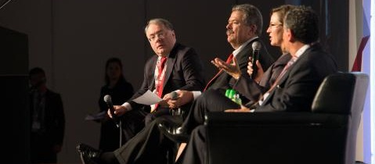
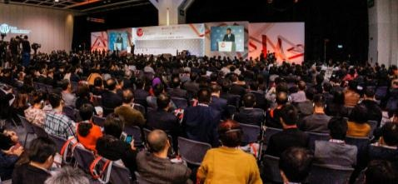 | - 20 breakout sessions  - IP Practical Tips  - Industry Specific IPs  - Sessions powered by IIPCC,  ITTN and APAC Innovation Summit
- Networking events to meet and greet your close and potential partners  - An expanded exhibition zone  featuring key IP-related companies for IP and business consultations | 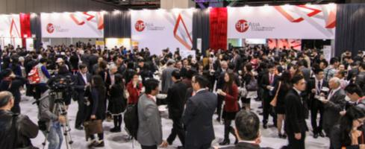
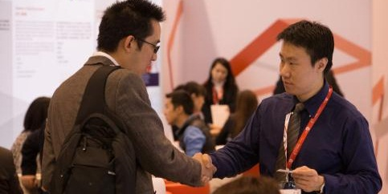 | - Speed networking sessions to quickly connect with more business contacts  - One-on-one business-matching meetings to explore cooperation opportunities
Special Offer for members of LSCM R&D Centre*: | Original registration fee: HKD1,600 | HKD500  (two-day pass, Networking Lunch on 4 Dec)  (Promo Code: BIP2014SO_52)

* Register and pay in full on or before 31 October 2014 (Friday) to enjoy the discount.

Mark Diary NOW!

MARK YOUR DIARY on 4-5 December 2014!
Stay Tuned @ www.bipasiaforum.com for the latest programme!
Click here for online registration

Organisers:
 | 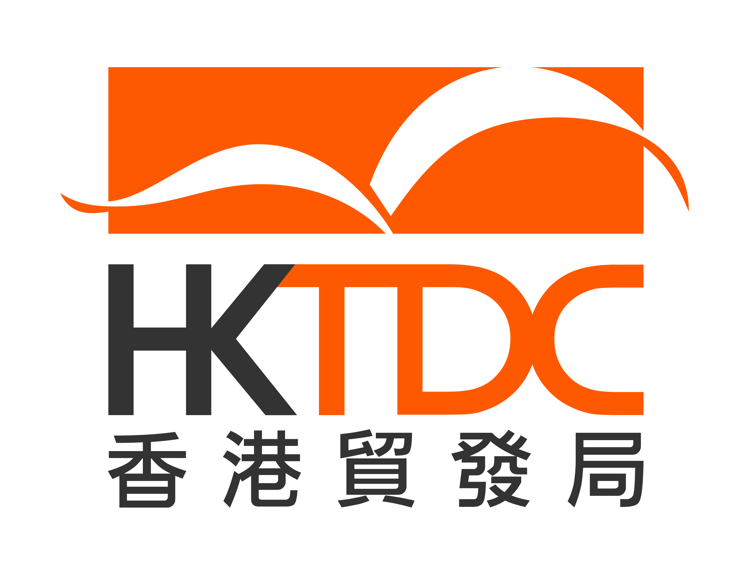 | 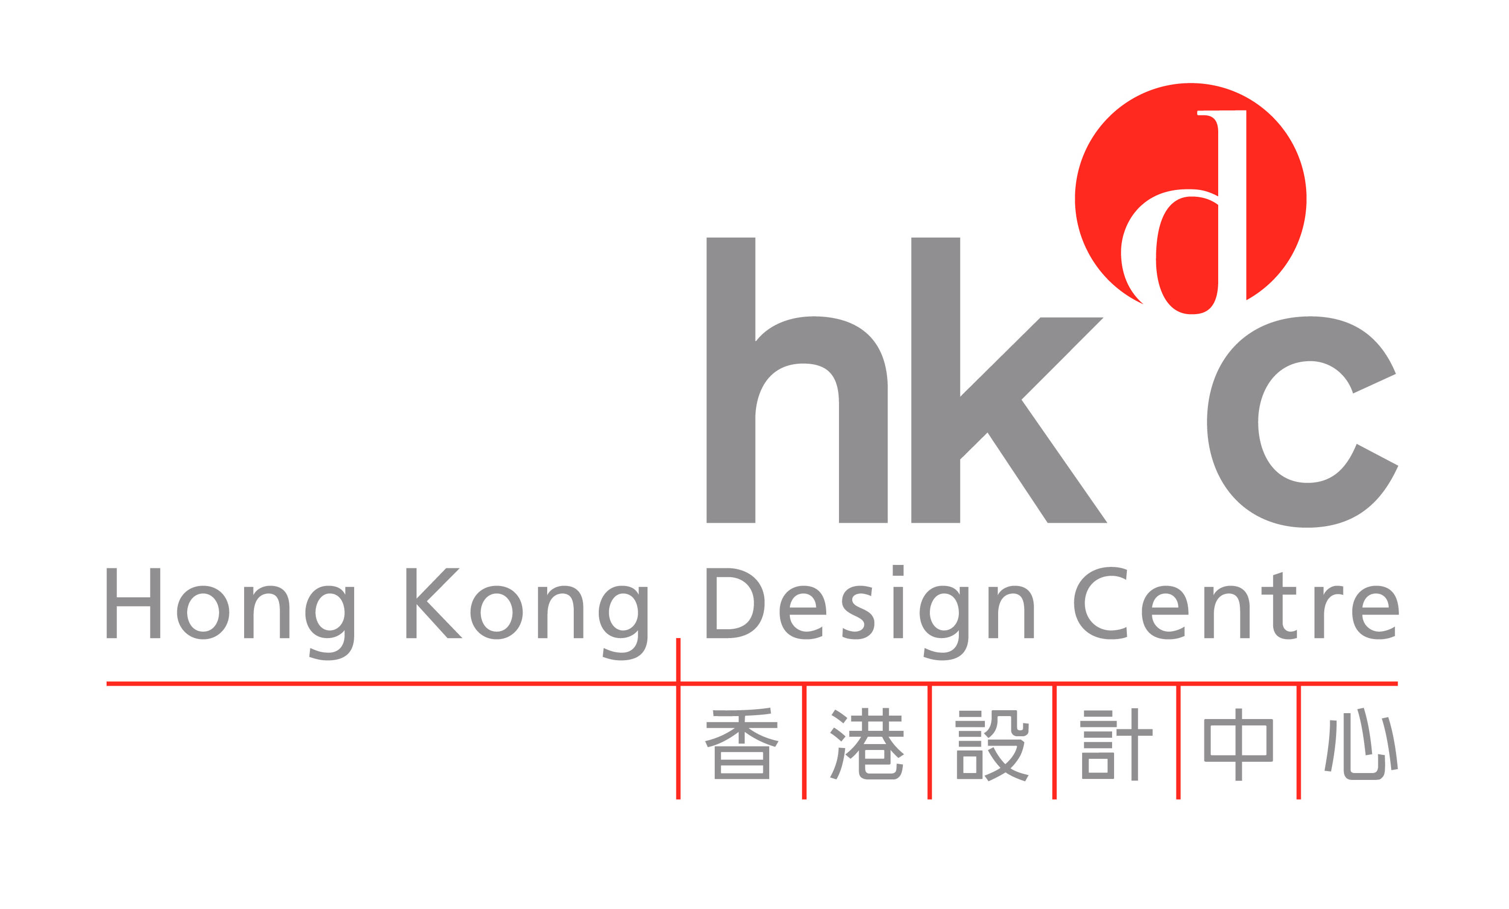
An Event of


Concurrent Events:
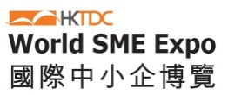 |  | 

Enquiries:
Mr. Hayens Luk | Tel: (852) 2584 4011 | Email: hayens.hl.luk@hktdc.org

